# Stage 3 Report: A better Connect

# Socially Awkward Penguins

|  |  |  |
| --- | --- | --- |
|  |  |  |
| Evan Louie |  | Jeff Chan |
|  |  |  |
| Weifon Liu | Pen-GUI | Sandy Fang |

## Part A1: Low fidelity Prototype

Inheritance

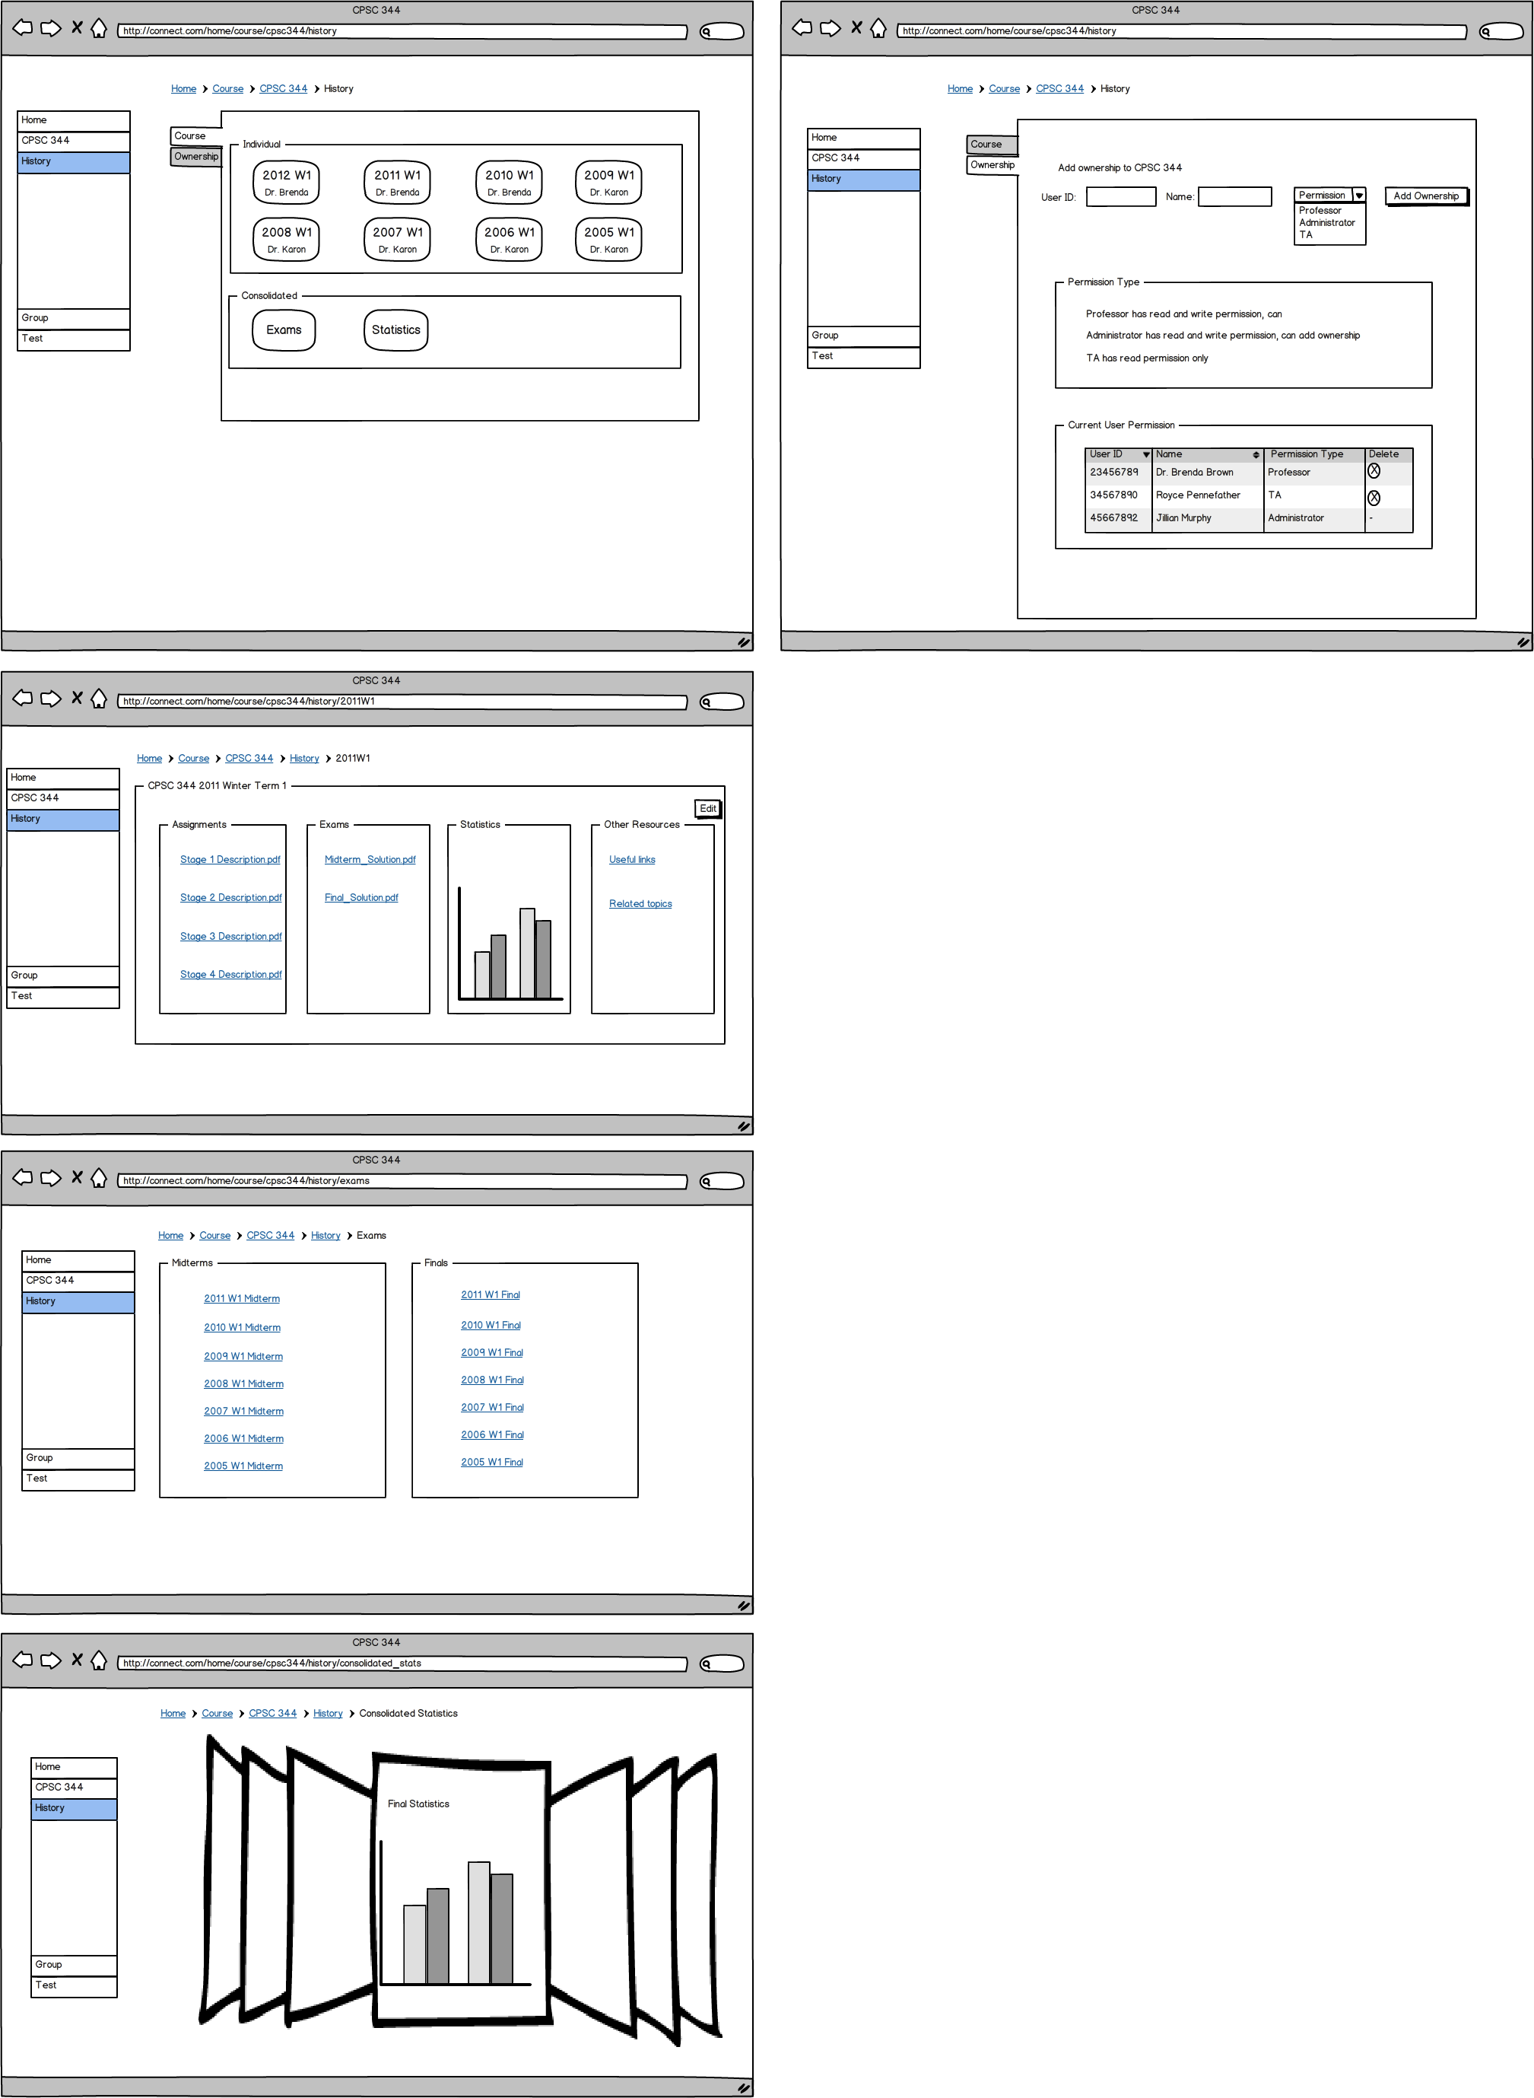

Quiz Creation

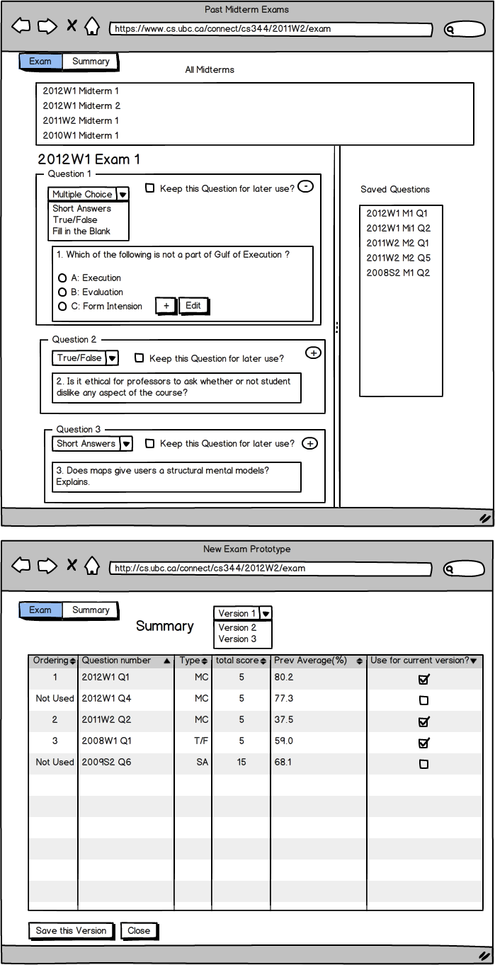

## Part A2 Description and Walkthrough

## Description

After individually sketching out the design approach according to our team’s task examples, we did a quick demo and walkthrough on the different design.  We kept in mind that Connect is confusing the user in a way that it provide too many functionalities in a single page so we try our best to make our UI as simple-looking as possible.  As a group, we chose the rough design of the most intuitive and clean-looking UI that has vertical tabs to continue on to the low-fidelity prototype.  
  
Since all three task examples from Stage 2 are supported by the interview results, we try to fulfill all three task example into our prototyping.  However, we realized that it is not quite possible to do since we only have 4 people with limited time. We prioritize the three tasks to be inheritance, test creation and then group creation and management. We hope to have all three done but as of the time constraint, we have completed the first two.  
  
The low-fidelity prototyping tool that we use is called myBalsamiq.  myBalsamiq is great for building simple web interfaces and it is exactly what we look for. The inheritanc e prototype can show the user how adding a ownership will look like and how to access the history of previous year’s course as well as showing a simple stats chart that they could see. The test creation prototype shows the user how to view the prvious tests and create a test. Previously the professors has indicate that inheritance would be a positive addition to Connect as well as improving test creation would make them more likely to create test in Connect.

The purpose for the prototypes is to provide general design to show some of the functionalities that we wish to have in inheritance (or history) and test creation. The significance, for the team, is to understand each other’s reason of designing the prototypes in a certain way as well as to agree among a common area for the UI (say the menu bar is always on the left-hand side and that we always want to use a vertical panel). Also, the major purpose of the prototype is to get an understanding of the user when they first try to walkthrough our redesign. What are some of the areas that are too ambiguious? What is good and what is bad in our design? Can user understand what to do without much assistance from us?

The task examples we chose are the two examples under Task A.1 in this report. We have a more well-rounded task examples of inheritance and test creation compared to Stage 2. Both of the designs are going to be detailed enough so that the task example can be covered.

## *C:\Users\Sandy\Desktop\344_history\screen shots\4consolidatedStats.jpg*Walkthrough Report

Inheritance:

- originally there was no tabs for the main History page. That did not make the user think it is intuitive enough because course and ownership are two different objects and should be separated into different tabs.

- there was a minimize icon on the top right cornor for each items inside the tab as well as a hirizontal scroll bar. However, we took it out since each page is stright-forward enough to not contain too many items.  
- adding ownership to courses was straightforward

- the delete button was at the very beginning of each row in the ownership tab, moved it to the end so it is vidually more accepting

-edit button did not work in the low fidelity prototype, we eliminated it in the walkthrough and just described what it will do

- the simplistic UI made finding previous course material very easy  
  
Exam creation integrated with inheritance:  
- the prototype only has two pages and, without animation, user is more or less overwhelmed  
- Saving different version of the same exam can be a hard-to-get concept  
- It is not obvious how changing question type really works with a 2 page only prototype  
- Our cognitive walkthrough showed that users can do “selecting different exams, editing questions, saving questions, and customizing different final versions”

## Appendix A.1 Revised Task Examples

## Inheritance

Dr. Brenda Brown is a UBC computer science professor who is currently teaching CPSC 344, CPSC 410, CPSC 121, and CPSC 110.  She has been teaching CPSC 344 for the past 3 years and is about to teach a different computer science course.  Dr. Brad Williams (with user ID 43957247), who is about to take over CPSC 344 has asked her to share any useful materials with him.  Brenda, who has always been very careful to document, take notes on her course have gathered 3 years’ worth of knowledge and resources in the course and thanks to the previous CPSC 344 professors for sharing the course resources with her, she did not have to create all the materials from scratch.  Before she shares the course resources with Brad though, Brenda remembers that the "Related topics" link in 2011 Winter Term 1 is no longer relevant and wishes to delete them so Brad wouldn't be confused.  Also, Brenda's TA, Royce Pennefather (user ID 68371055) is hired by Google and will no longer help out with the course.  Brenda wants to update the current user permission of CPSC 344 to not include Royce before sharing the course with Brad.  At the same time, Brenda wishes to continue her ownership with CPSC 344 so she can still view, edit and upload any contents.

Summary of Revision:  
This task example is changed to provide more insight into the specific task and what the user is trying to do and how course inheritance would benefit instructors. We also aim for design independence.

## Quiz Creation

Dave, a math professor of UBC, is currently teaching a math 210 course. This course has been around for many generations and Dave just got inherited the course materials, such as exams, practices, slides, and student performance data from the previous course. Before the midterm exam, Dave decide to mix and reuse the exam from previous two years. At first, he wants to see each exams, and, with the reference of difficulty rated by statistics of student grades on each question, he wants to choose some of the questions and add them to the attempt new exam. After adding questions, he wants to compare questions together and delete repetitive questions, so that he can, then, edit the remaining questions by changing some values around. Moreover, he also wants to change some questions from multiple choice to true and false, or the other way around with the reference of original exam answers and comments. Finally, he wants to save the template of these exams so that he can have multiple versions of the midterm.

Summary of Revision:  
This task example will be an integration of test creation and course material inheritance. It must involve viewing individual exam, saving questions to “exam prototype”, removing undesired questions from the prototype, editing questions, and populating different versions.

## Part B Evaluation Plan

Goals of Evaluation:

The key usability chanllenges or uncertainties in our project would be that we simplify the Connect UI a lot and the users who use Connect might be looking for some more features (and thus once again the Connect they use might have a messy UI again). It is impossible to know, at least in our course project’s scope, what are the most commonly used tools for all the users.

For inheritance, since we do not have an existing feature there and we know there must be a better UI to fulfill our requirement. We might falsely present a UI to the user and they might think it is very well-designed but once they started using it, they might want the layout to be different, or add in more functionalities.

For test creation, we face a similar issue with inheritance although we have an exsiting somewhat hard-to-use test creation tool in Connect. Will the user be requesting more functionalities eventually? Perhaps that is how Connect ends up having a complicated UI and we do not want to fall back to the same design.

We understand that there is always a better design and user experience would sometimes alter overtime, we can only access the current user’s need and thus we can only fulfill the current user requirement and try to think ahead to prevent future failure of design. With these above uncertainties in mind, we came up with the top three final list of goals:

1. Is the course inheritance (history) feature an effective and easy to use way of inheriting content from previous years?  
 2. Is quiz creation tools easy to use? Is it intuitive enough for users to create a quiz without assistance?

3. Are the features easy for the user to find?

Type of Evaluation:

For our Stage 4 evaluation, we will use observation. We will be sitting beside one single user and watch him/her do the assigned task. We figured it is easier to understand the user to use evaluatoin than interviews since we can provide the user with a prototype and watch them complete a task. We want very specific details about what users think and use of our prototype and observation provide a level of flexibility that no other method does better.

Participant Pool:

Our paticipant pool this time will consist of instructors who have or have not been using Connect. We did not want to eliminate student users, however, the two task examples that we are using are focus primarily on instructors due to time constraint. If possible, we would like to interview the same professor as last time so we can get feedback on the improvements made after their last interview. We would try to interview 4 instructors teaching in UBC on both task examples and see if they are able to complete the given tasks on their own.

Evaluation protocol

Our evaluation will take place in an environment that is free from distractions. The data will be collected as qualitative data rather than quantitative since we have a small participant pool and we expect the data to be detailed and personal. The instructors will be asked about all the features that we have and the instructor observation process will take approximately 20-30 minutes.

## Part C Medium Fidelity Prototype

Prototype Rationale

Our prototypes are mostly vertical prototypes as they focus on the specific features that we implemented based off our task examples. We want our features to be usable. The one part of our prototype which is horizontal is a new home page which we have made in order to access our features.

The functionalities that our prototypes provide are: the ability to inherit course content from previous years, the ability to create a quiz, inherit questions from old quizzes and creating a test.

We tried to make our prototypes look as appealing and realistic as possible, but it was not that important to us. The focus of the prototypes is the functionality and usability.

The tools we have used to create our prototype are Visual Basic for the quiz creation and Advanced HTML for inheritance. These tools were picked based off the skills of each member and what could be used to create what we need most efficiently. Advanced HTML is ideal since our product is a webpage, but for quiz creation which is a complex feature, Visual basic was used since it was more efficient for our needs.

## Illustrations

|  |
| --- |
|  |
|  |
| Figure 1.1 Homepage. What you see when you first log in |
|  |
|  |
| Figure 1.2  Course Homepage. What you see after you’ve selected a course from the Homepage |
|  |
|  |
| Figure 2.1  Course inheritance main page |
|  |
|  |
| Figure 2.2 The view of course inheritance after you’ve selected a year of the course |
| C:\Users\Sandy\Desktop\344_history\screen shots\5Ownership.jpg  Figure 2.3: The owership tab view. Users can add user ID, name and select type of ownership to add wonerships to. They can also delete permission. (except TA has read permission only).  C:\Users\Sandy\Desktop\344_history\screen shots\3consolidatedExams.jpg  Figure 2.4: The consolidated exam view. Viewer can see how they can access to previous exams. |
|  |
| Figure 3.1  Inheriting quiz questions from previous quizzes |
|  |
| Figure 3.2  Summary of a quiz composed of inherited questions |
|  |